**Chapter 3**

**METHODOLOGY**

This chapter contains the project design including the flow chart, block diagram, use case diagram, circuit diagram, and isometric view of the project design. And project development

**Project Design**

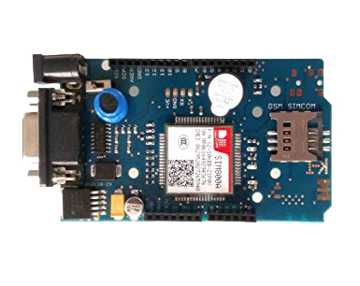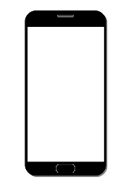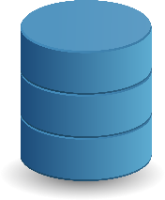

Database

Phone

GSM

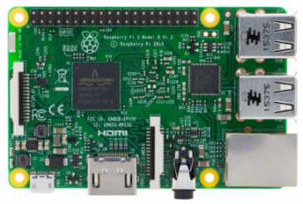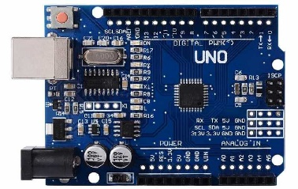

Rasberry Pi 3

Arduino Uno 3

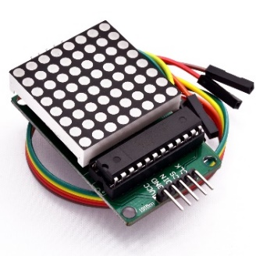

Dot Matrix

***Figure 2.*** Block Diagram



Record in Database

Display Messages

Professor

Input Announcement

View Database

***Figure 3.*** Use Case Diagram